PD Tracker+ (Vector Solutions)
How to Apply for Course Reimbursement
- Log into your Vector Solutions account
- Click on the Graduation Cap located on the left-hand side
- Click NEW (green button in the upper right-hand corner
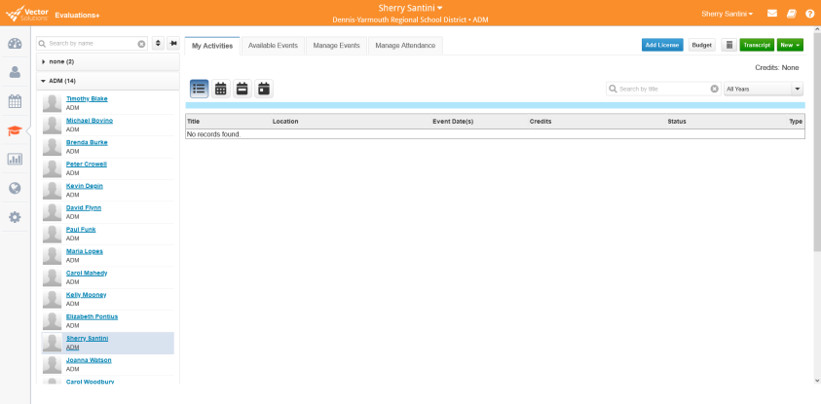

- Choose: Request for Reimbursement
Required Fields:
- Title
- Asynchronous/In-Person (if it is a combination, choose In-Person)
- Start and End dates
- Location (where does the course take place)
- Name of Organization or University
- Registration Fee or Course Cost
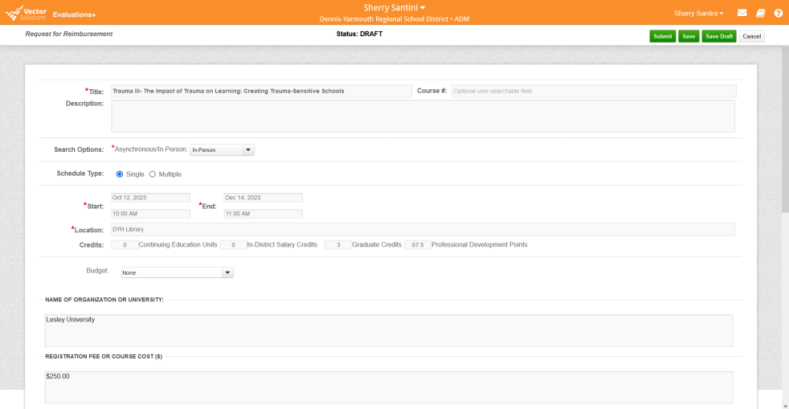

- “Tagged” appropriate rubric indicators using the tag icon below (The indicators for Support staff is first; continue scrolling for Teacher indicators)
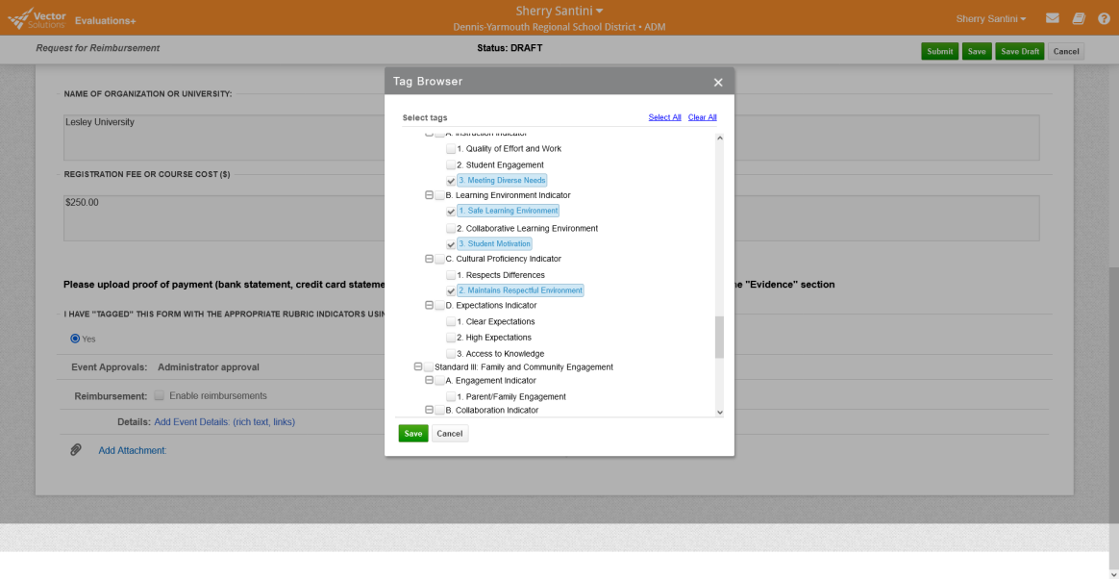
- Details (description of course/activity)
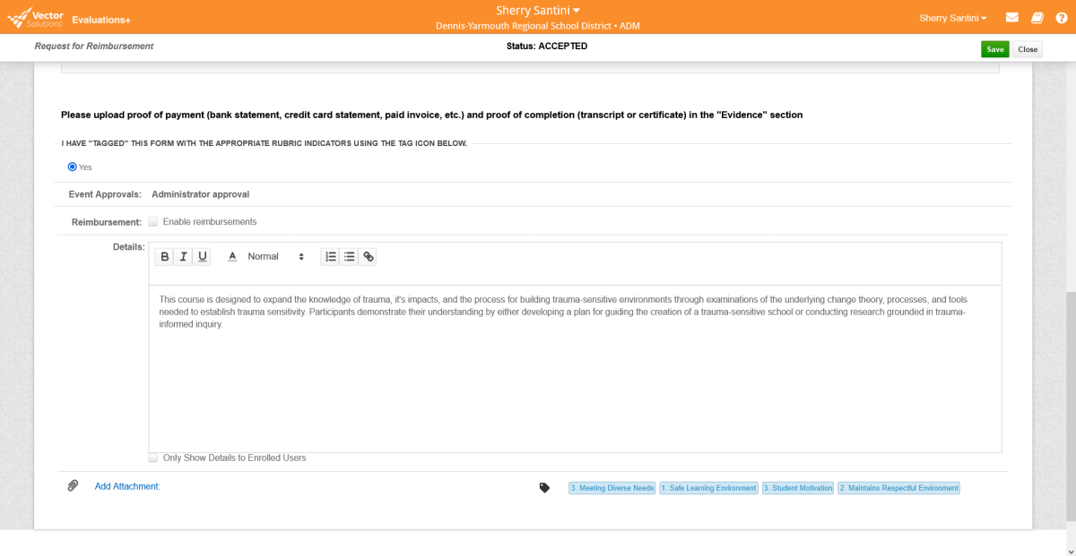
- Click on “Submit”. Your course will be approved by one of the Directors of Instruction.
- Once you have completed the course, you will submit your evidence (proof of payment and proof of completion/transcript) by uploading the documents directly into the platform.
