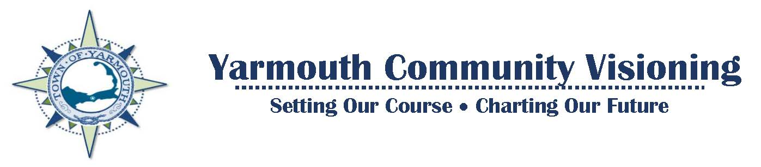
Make a New Year’s Resolution
Take the Community Visioning Survey!
Your ideas and feedback will be used to create a Vision Plan which will provide valuable insights to our Town Leaders when identifying future goals, initiatives and resource allocations to better serve our residents and meet our collective vision for Yarmouth.
These decisions will help decide how your tax dollars are spent. So don’t let the few decide Yarmouth’s future for the many!
Visioning Survey https://www.surveymonkey.com/r/M2MZFCW
(Survey has been extended through January 31, 2021)
Share the Survey Link with Family, Friends & on Social Media. Help us get the word out about this important community project!
The survey asks three simple questions:
- What are Yarmouth’s strengths and assets that you value and want to preserve?
- What are our challenges?
- What is your future vision for Yarmouth and what are the opportunities to help us reach that vision?
You can say as little as you want or as much as you want, just let your voice be heard!
The Survey is also available in Portuguese and Spanish:
- Portuguese: A pesquisa também está disponível em português:
https://www.surveymonkey.com/r/YarmouthPortuguese
- Spanish: La encuesta también está disponible en español:
https://www.surveymonkey.com/r/YarmouthSpanish
For more information on the Community Visioning project and to sign up for direct updates via e-mail, go to the Community Visioning webpage at:
http://www.yarmouth.ma.us/1838/Community-Visioning

